

Use guide

Karnel Travel Guide



[Date]

group 4

FPT APTECH HCM

1. **Restore Back up**

**Step 1: Open SQL Server Management Studio**

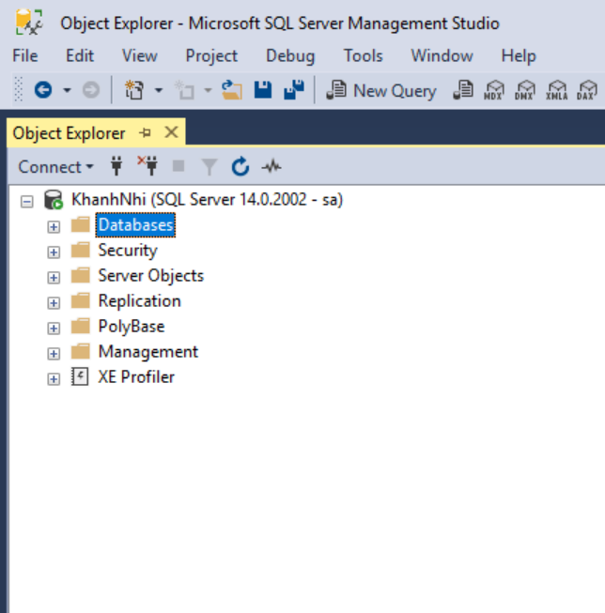

Right click Database choose Restore Database…

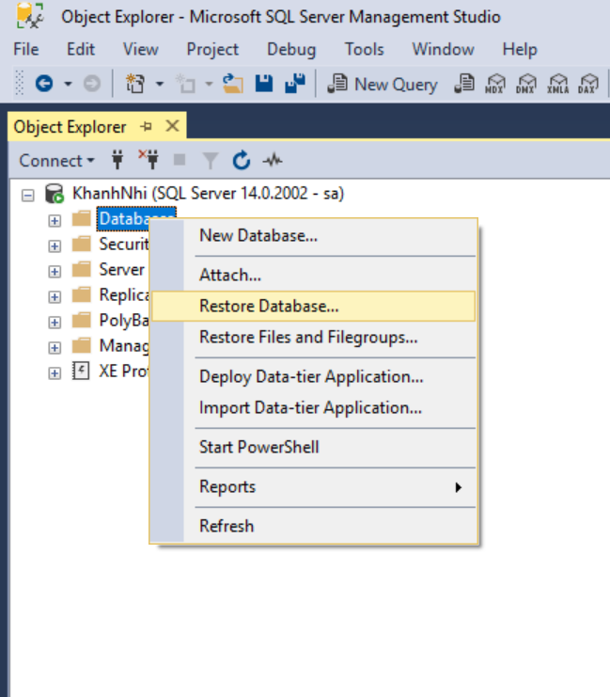

Show Restore Database Table Choose Device and choose Brown (**…**)

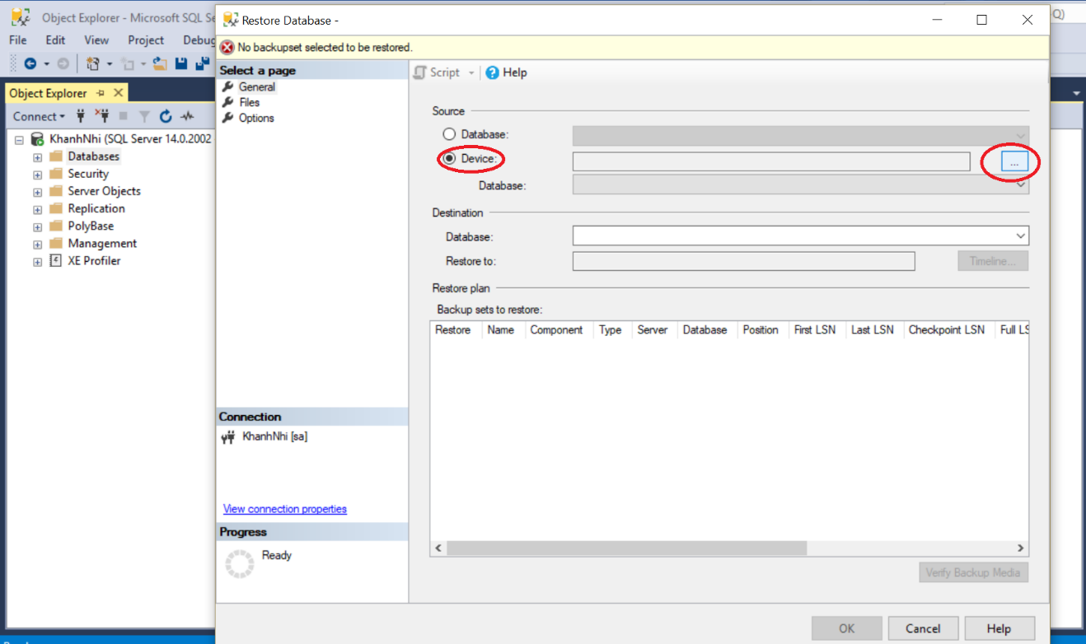

Show Select backup device table choose Add

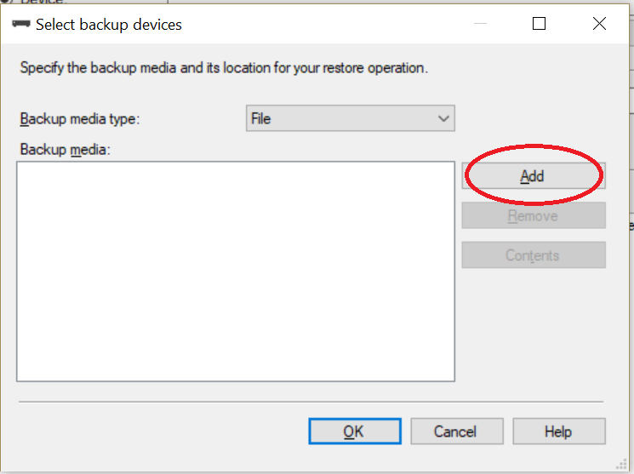

Show Locate Backup file table, Choose path D:\E-Project_KarnelTourGuide\E-Project_KarnelTourGuide\Source\Database\Backup DB\ TravelGuide.bak. Choose file *TravelGuide.bak, Click OK*

* *(Note: File TravelGuide.bak should locate at Disk: D:\)*

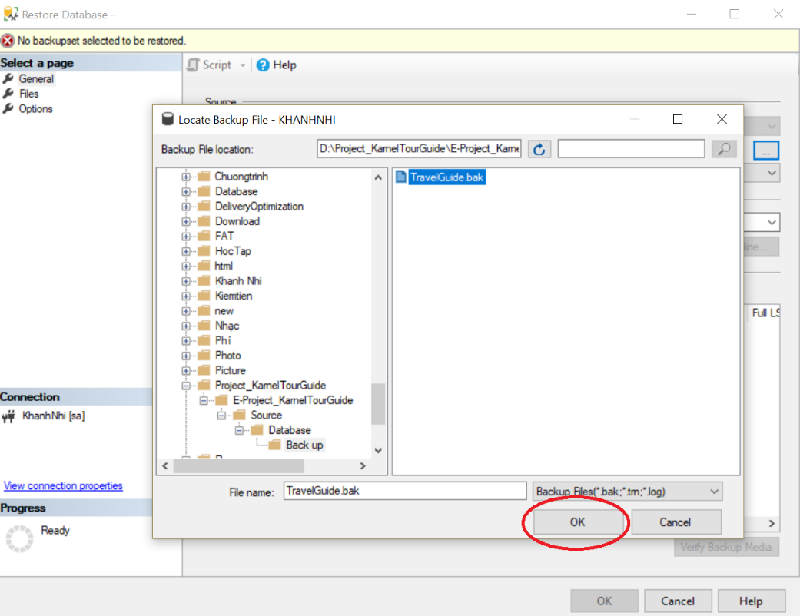

After click OK on Show Select backup device table

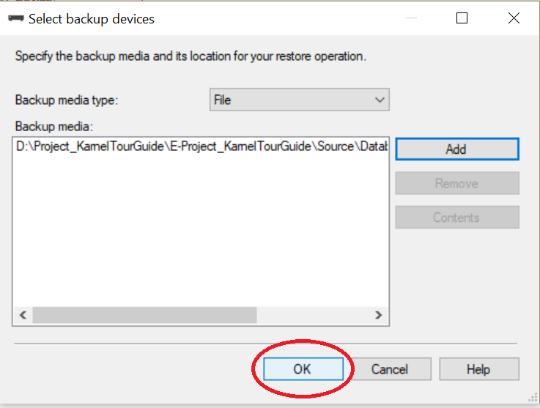

After click OK on Restore Database Table

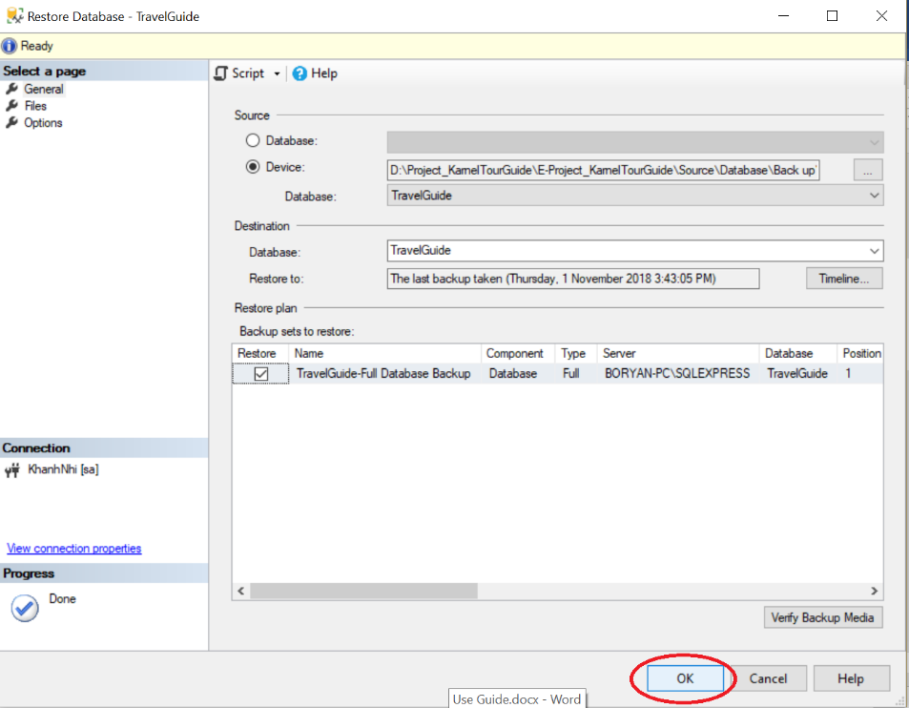

Show notification *Database ‘TravelGuide’ restored successfully*. Click Ok

Database ‘TravelGuide’ restored.

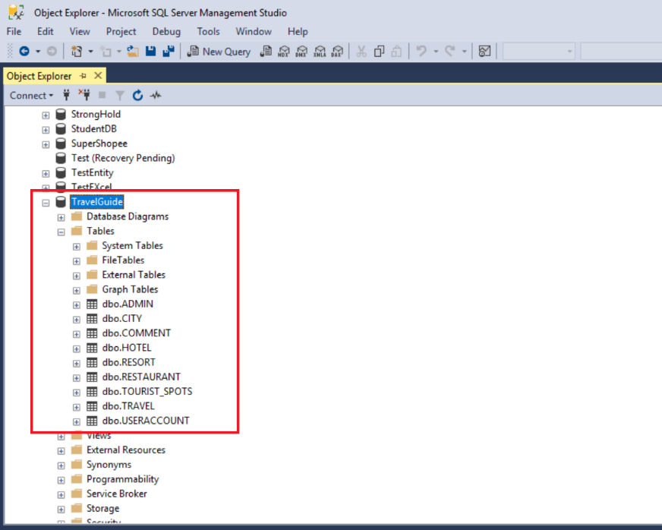

1. **Run Project**

**Step 1: Download and install SQL Server 2017, Visual Studio 2017 and Project.**

**Step 2: Open project solution by Visual Studio 2017.**

**Step 3: Open file Web.config**

Change your Data Source, User Login and Password SQL Server

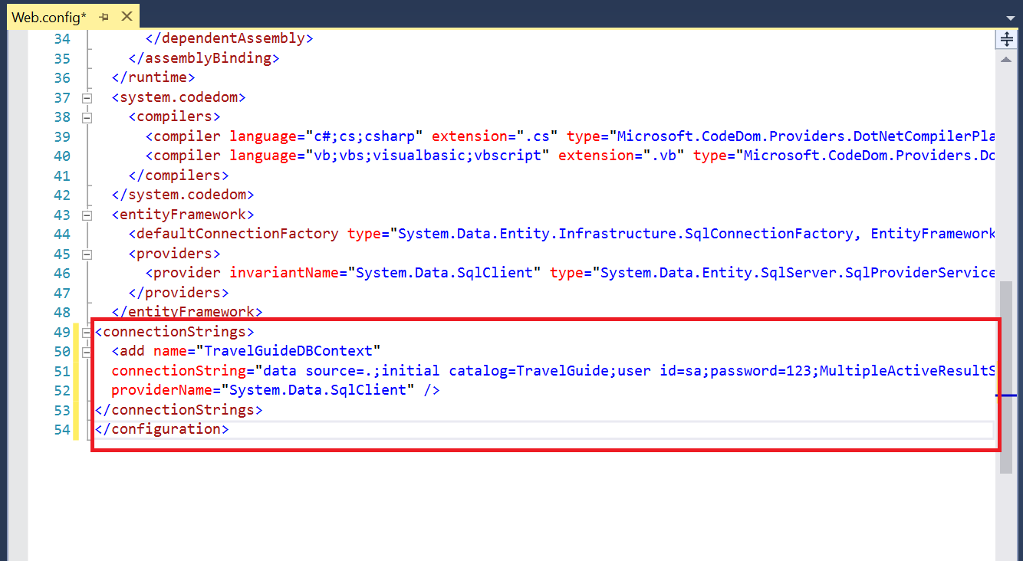

**Step 4: Right-click solution, chose Build (or F6 key on keyboard)**

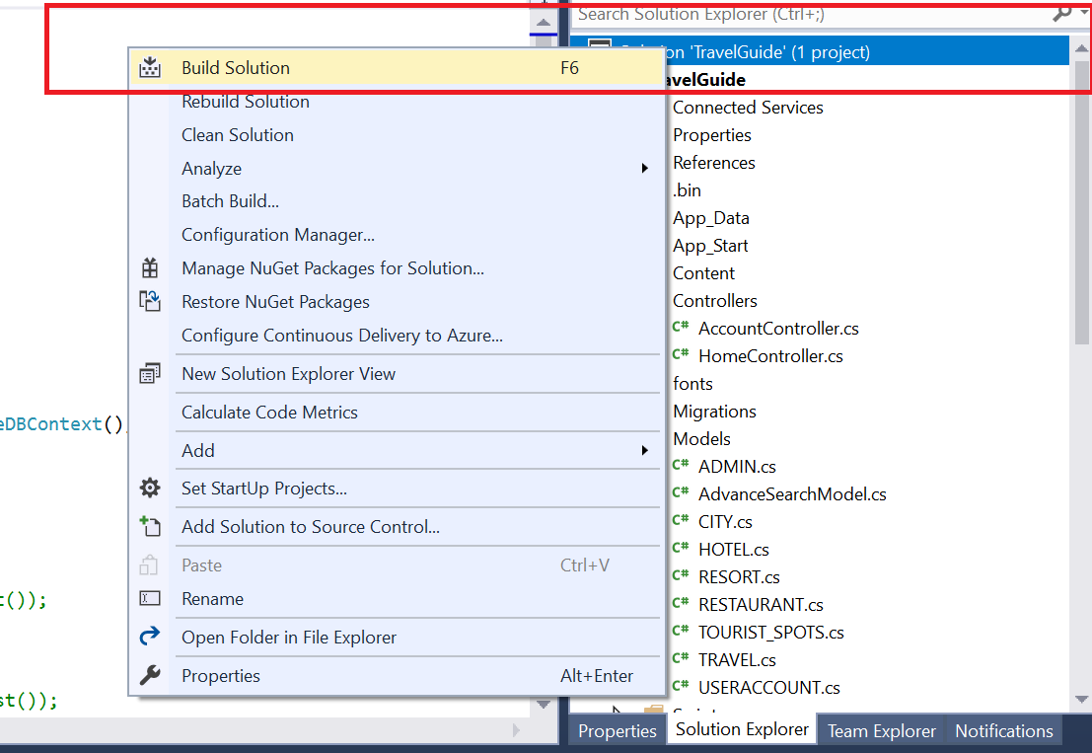

**Step 5: Run IIS Express.**

Choose your browser

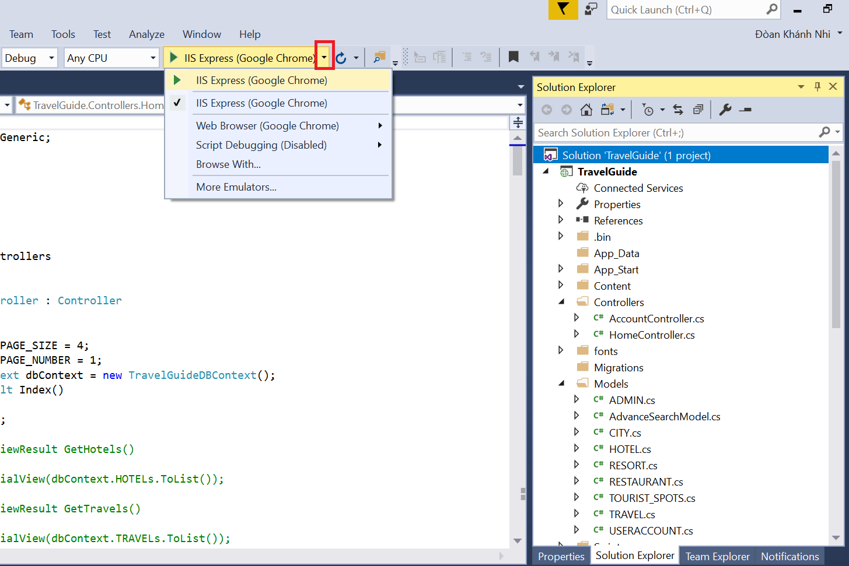

*Click IIS Express (Your browser) for Run Project*

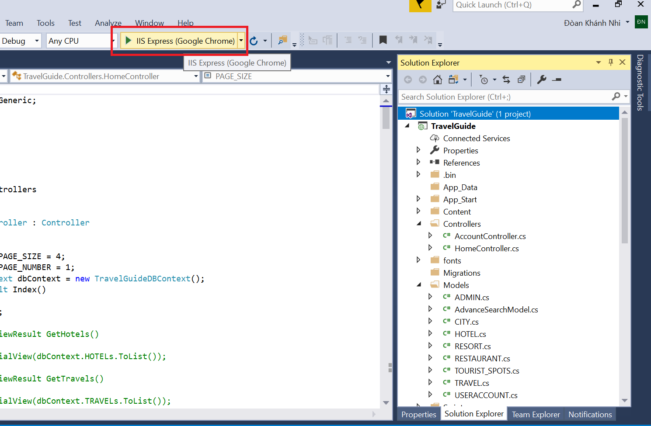

**Step 6: Show Website in Browser**

